2016-2017 Music Window Decals One Form per Student
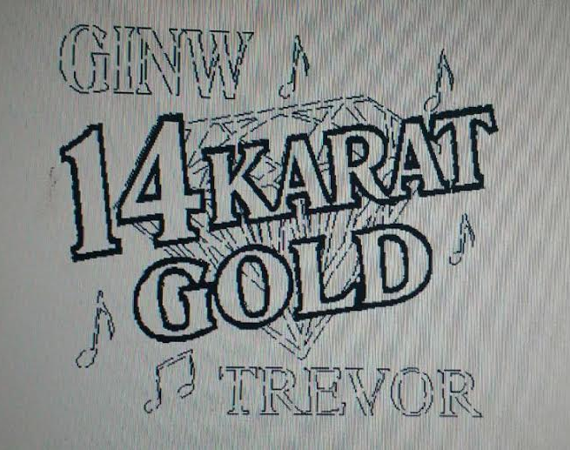
Quantity_________ Quantity________ Quantity _________

Quantity_________ Quantity________ Quantity _________
Quantity________ Quantity__________ Quantity _________
Name (How you want it on decal) ______________________________________
Student Full Name___________________________ Phone_________________
Total # of Decals @ $10.00 each ___________ Pd Cash/Check (Circle One)

***You may write one check for multiple orders, but please fill out one form for each student.***

Mail to: SaDonna Manfull
1623 Lariat Lane Orders Due Thursday,
Grand Island, NE 68803 November 10, 2016
If Questions Call/Text (308) 216-0216

