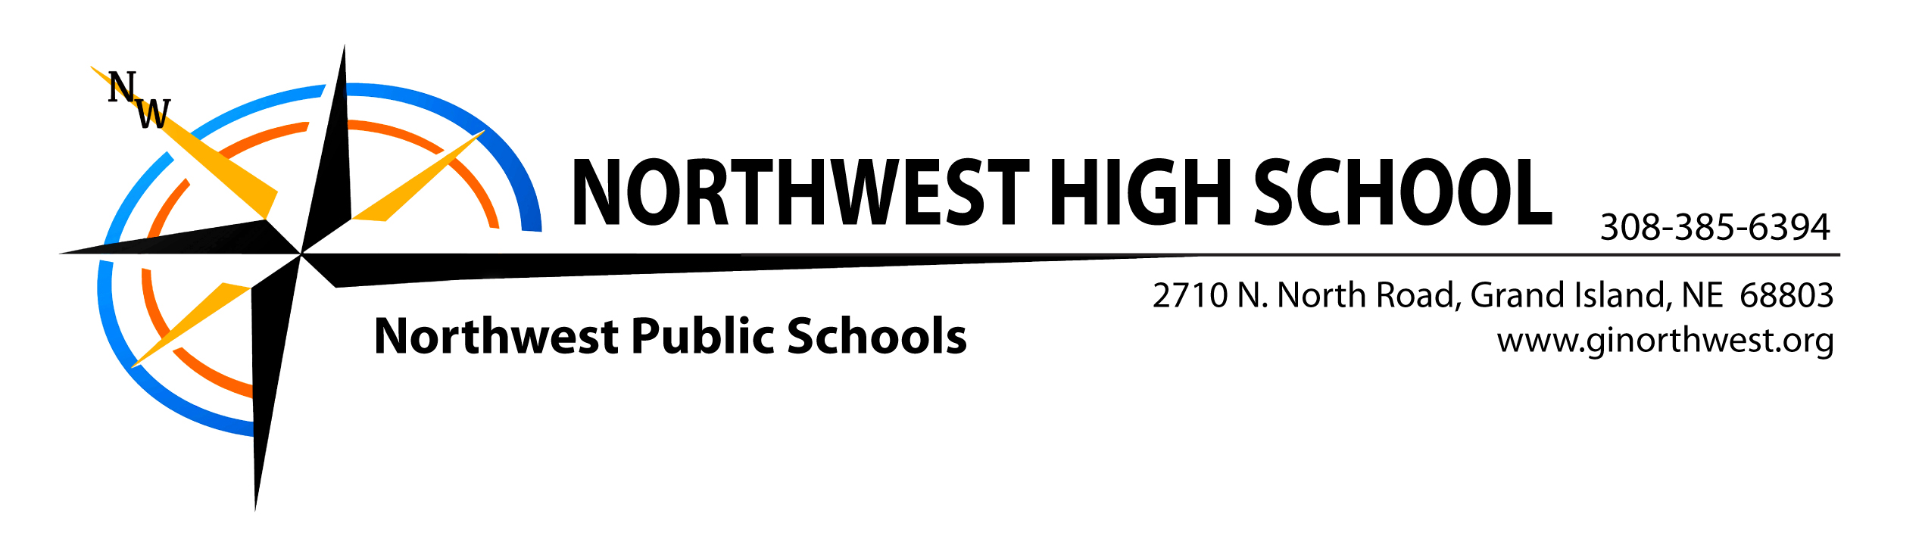

January 2017

Dear Future Viking

Please consider this your invitation to join all prospective students and their parents at 8th Grade and New Student Orientation Night to be held Thursday, February 2, at Northwest High School.

Open House will begin at 6 pm. Teachers will be available in their classroom to answer any questions and explain their curriculum offerings. Registration begins at 6:45 near the auditorium, followed by a short thirty-minute program featuring the jazz band, school activities, video production class, as well as information from counselors and administrators, all starting at 7 pm.

Following this program, students will go on a tour of the building led by Student Council and National Honor Society members; parents will stay in the auditorium for an informational session. After the parent meeting and tours, all of the activity groups will have displays in the gym where you can meet the coaches/sponsors and learn more about participation in these activities.

At 8:15 pm., the door prize drawings will begin. The evening concludes at 9 pm.

Enclosed in this packet you will find a registration form, a course description booklet and a brochure. The counselors will be available to meet with students during the evening and will also be available to meet with students and parents on Wednesday, February 15, from 4:00 to 7:00 p.m. in the cafeteria to answer questions and collect registration forms. You may also turn in your registration form the night of orientation.

We look forward to meeting you on February 2nd. If you don’t currently attend school at Cedar Hollow, One-R, Chapman, or St. Libory and have not yet completed an option enrollment form, you may call Kim or Barb in the Superintendent’s Office at 385-6398 or email kgibson or bhuls@ginorthwest.org with any questions regarding option enrollment.

Sincerely

Northwest Administration and Staff

