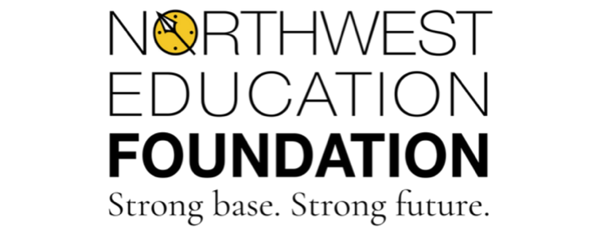
Charting our Future

Northwest Public Schools Staff Donation Form

I, ______________________________, do hereby subscribe and agree to contribute and promise to pay to the Northwest Public Schools Foundation (acting as fiscal agent of donations for the Athletic Complex Renovation Project) the sum of $___________________, in consideration of this and other pledges to be used for the Athletic Complex Renovation Project.

I understand that this pledge can be given as a one-time donation or given over up to 3 years. The entire pledge, or first installment of a three-year pledge, will be made on or before ____________________________.

_______ One-time donation: ☐ Check ☐ Credit Card

_______ Installment plan: ☐ Monthly*** $_________________
(up to 36 month) # months___________
☐ Quarterly
☐ Annually in the month of __________________

Credit card information: Credit Card # ____________________________
(if applicable) Exp. Date ___________ CSC ____________

Name on Card_______________________________________________

***If you would like your monthly pledge to be contributed through payroll deduction,

please sign here: ____________________________

(For pledges longer than the school fiscal year, a new form will need to be signed. Staff that leave the district and are no longer eligible for payroll deduction, will need to provide pledge amounts via check or credit card, or make necessary arrangements with foundation personnel).

I understand that my pledge will be subject to all investment and administrative policies of the Northwest Public Schools Foundation. This is the entire agreement between the parties and may be altered only in writing signed by the parties.

Donor______________________________________________ Date _____________________
Signature

Name for Recognition Purposes ___________________________________________________

Contact Name _________________________________________________________________

Address_______________________________________________________________________

City__________________________________ State_________ Zip________________

Phone______________________ e-mail ______________________________ ☐ Prefer to remain anonymous

Accepted by the Northwest Public Schools Foundation: _____________________________
*Donations are tax deductible

